**Solutions to the questions**

The time series graphs for the variables is:-

1). Year against GDP

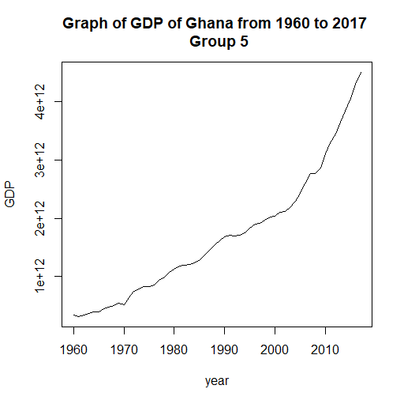

**Interpretation**

There is a positive linear relationship between GDP and the year

2). Year against Gross investment

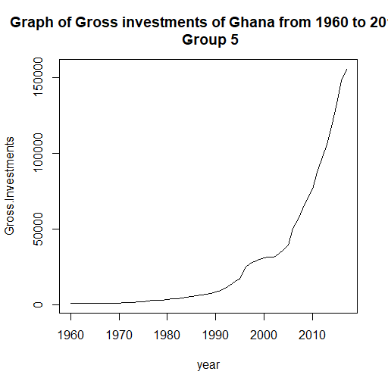

**Interpretation**

There is a positive linear relationship between gross investments and the year.

3). Year against Consumer price index

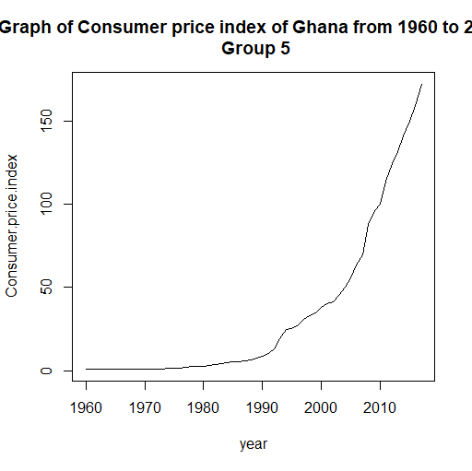

**Interpretation**

There is an positive linear relationship between consumer price index and the year

Part two:-

**Hypotheses**

The null hypotheses are,

H0: There is no significant influence of gross investment and CPI on GDP

The alternative hypothesis is,

H1 : There is significant influence of gross investment and CPI on GDP

**Confidence level**

We test at significance level of 0.05,

**The OLS model is**

GDP=945600000000-6713000(GI)+27390000000(CPI)

**The interpretation of the model**

With gross investments reducing by 6713000 and consumer price index increasing by 27390000000, It causes one unit increase of GDP, all factors held constant.

**R squared** is 0.9017, it implies that the estimate is a good fit. And 90.17% of the variation is explained by the variables in the model. The model also found out only the consumer price index as a variable was significant at 95% confidence level.

**The F-test**

The calculated F-value at alpha, 0.05 is (252.3). for the tabled value of F at 0.05 for 2 and 55 degrees of freedom is 19.40. Since the fcalculated is greater than the f-table, we reject the null hypothesis and conclude that there is significant influence of the gross investment and consumer price index on GDP.

The diagnostic tests.

We want to look at the assumptions of ordinal least squares which are:-

1.) Independence of each data points

2.) Correct distribution of the residuals

3.) Correct specification of the variance structure

4.) Linear relationship between the response and the linear predictor

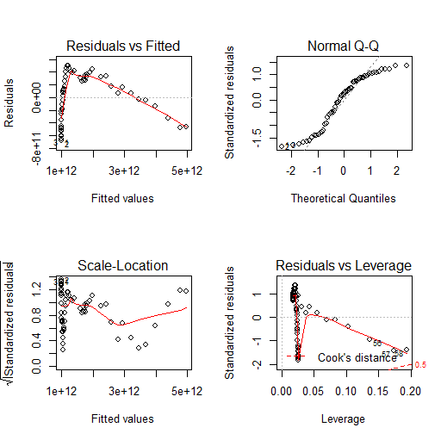

The diagnostic test shows the various relationships between GDP and gross investments this are the interpretation:-

1. There is very little homogeneity of variance and but there is a negative linear relation, when we look at the pattern in this graph. Then your assumptions are met.
2. The second graphs check for the normal distribution of the residuals, most of the points fall on a line.

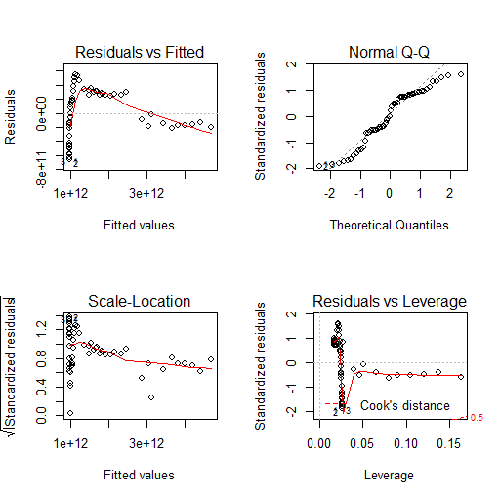

The above diagnostic test shows the various relationships between GDP and consumer price index this are the interpretation:-

1.) The top-left graph check for the homogeneity of the variance and

2.) There is a linear relation, then your assumptions are met.

3.) The second graphs check for the normal distribution of the residuals, the points fall on a line

**The comparison between the diagnostic test and the results of the OLS model**

The diagnostic shows that there is more homogeneity in the variance in the relation between the GDP and consumer price index compare to the relationship between the GDP and the gross investment. Which the OLS model clearly show with the R-squared which implies that 90.17% of the variation is explained by the variables in the model.

The diagnostic and the OLS model both shows linear relationship since we can see that most points fall in line. And the OLS model reports a positive linear relationship for the consumer price index and a negative linear relationship for the gross investments.

We conclude that the assumptions of ordinal least squares have been met.